EASO Management Board selects new Executive Director and elects new Chairperson

* 18TH FEBRUARY 2019

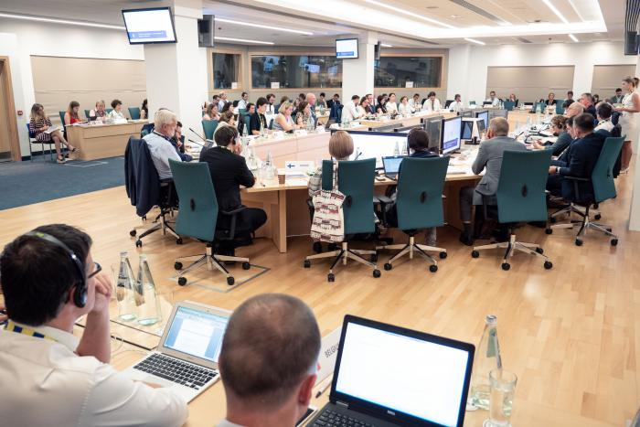

***The 31st meeting of the European Asylum Support Office’s (EASO) Management Board has selected Ms. Nina Gregori to be the new Executive Director of the Agency. At the same meeting, the Board elected as its new Chairperson, Dr. David Costello, Member of the Board from Ireland, following the end of Mag. Wolfgang Taucher’s term in January 2019. The Management Board also elected Mr. Mikael Ribbenvik as the new Deputy Chairperson.***

**Ms.** **Nina Gregori**, a Slovenian national, was selected by the Management Board to serve as the new Executive Director of EASO by the Management Board on 18 February 2019. Ms. Gregory currently serves as Director-General responsible for the area of asylum, migration, integration, internal administrative affairs and naturalization, within the Slovenian Ministry of the Interior.

The European Parliament will issue an opinion on Ms. Gregori’s selection following a hearing which will take place on 11 March in Strasbourg. The Management Board will then take the opinion into account before making a formal appointment.  Until the procedure is formally completed and the new Executive Director takes up her duties, Mr. Jamil Addou will continue to serve as Executive Director *ad interim*.

The Management Board also elected as its new Chairperson, **Dr. David Costello**, Member of the Board from Ireland. Dr. Costello, an Irish national, is the Chief International Protection Officer and Head of Ireland’s International Protection Office (IPO). He was formerly the country’s Refugee Applications Commissioner and has served as Deputy Chairperson of the EASO Management Board since 8 June 2015.

Prior to taking up the positions of Refugee Applications Commissioner and Chief International Protection Officer, Dr. Costello was Director of Asylum Policy in the Department of Justice and Equality. Among his responsibilities were the development of domestic and EU/international asylum policy, including legislative aspects.

Dr. Costello was educated at Trinity College, Dublin, University College Cork and University College Dublin from which he holds graduate and postgraduate qualifications in public administration, law and governance.

Following his election, **Dr. Costello**, who took up his responsibilities with immediate effect, stated: “*It is a privilege to be selected to Chair the EASO Management Board. This is an exciting time for the Agency, which is growing both in terms of staffing as well as its responsibilities and deliverables. I look forward to working closely with all my colleagues on the Management Board and with the great staff of EASO to further strengthen the Agency’s governance framework and implement work priorities. These include support for Member States’ asylum processes in areas such as training, operational support, country guidance and the quality of decision making in the context of the operation of the Common European Asylum System. I also want to personally thank my predecessor, Mag. Wolfgang Taucher, member of the Management Board from Austria, for the extraordinary work he did during his two terms as Chairperson and previously also as Deputy Chairperson of the EASO Management Board. His work and dedication cannot be understated and I am committed to carry this forward in the best interest of the Agency.*

The EASO Management Board also elected **Mr. Mikael Ribbenvik**, a Swedish national, as its new Deputy Chairperson. Mr. Ribbenvik is Director General of the Swedish Migration Agency (SMA). He served as Director for Legal Affairs of the SMA between 2008 and 2013, responsible for internal jurisprudence. From 2013 to 2016 he was Director of Operations and Deputy Director General responsible for managing and improving standards of performance within the operation of the SMA.